Eduardo Gallego Chillón

2º DAW | IES Francisco Ayala (Granada)

MongoDB Installation guide

1. Add MongoDB to repository.

* Adding official repository key.

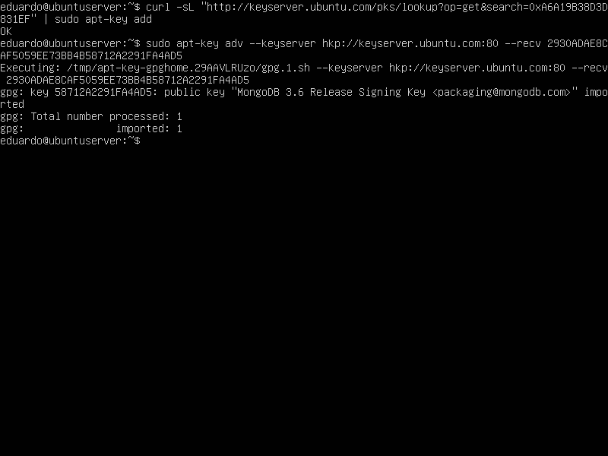

* Adding Mongo DB to repository.

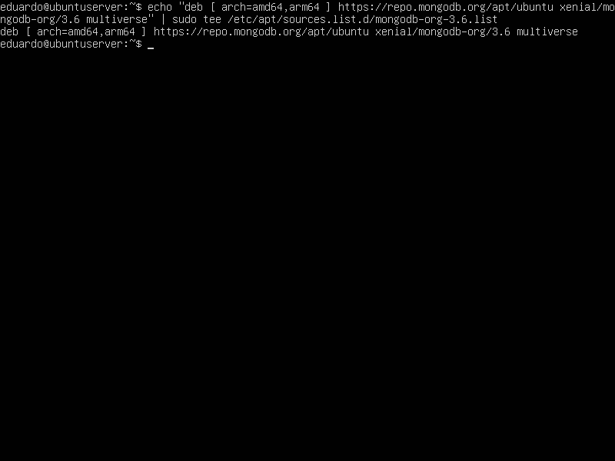

1. Install MongoDB on Ubuntu.

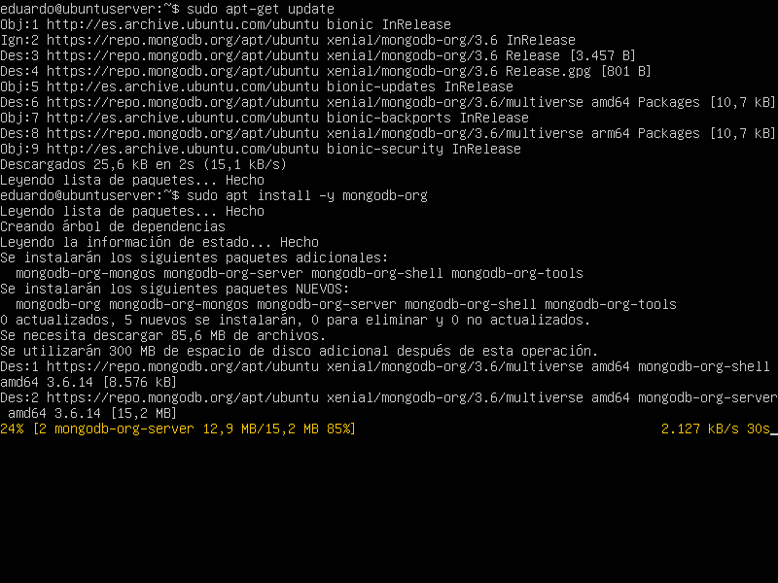

1. Stop, start and activate MongoDB for automatic start.

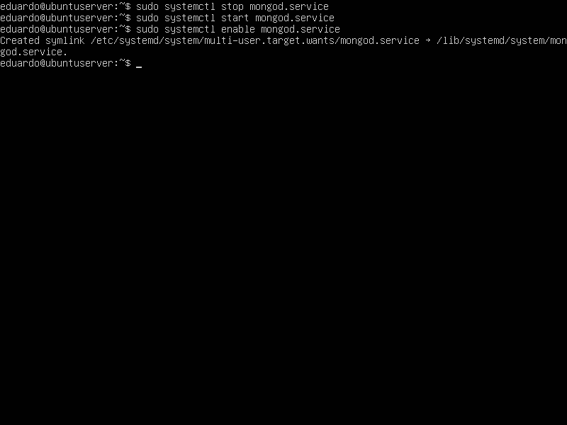

* Test if MongoDB is running.

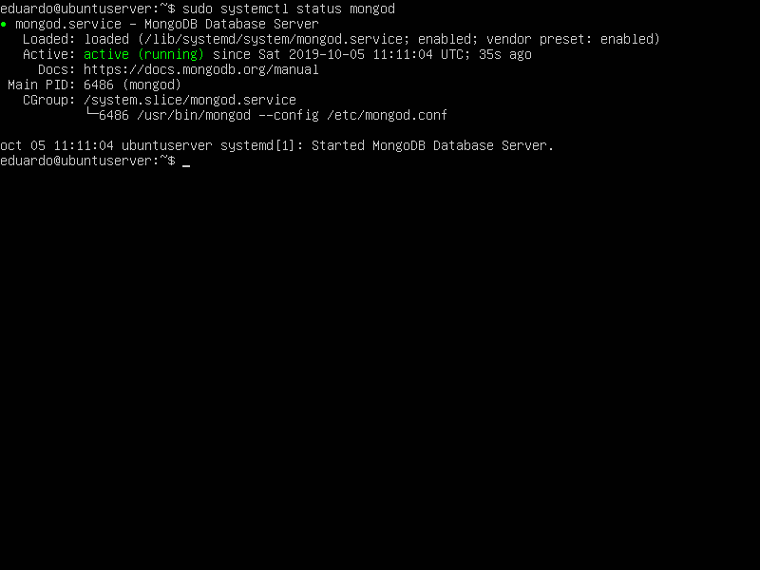

* Connect MongoDB to the shell.

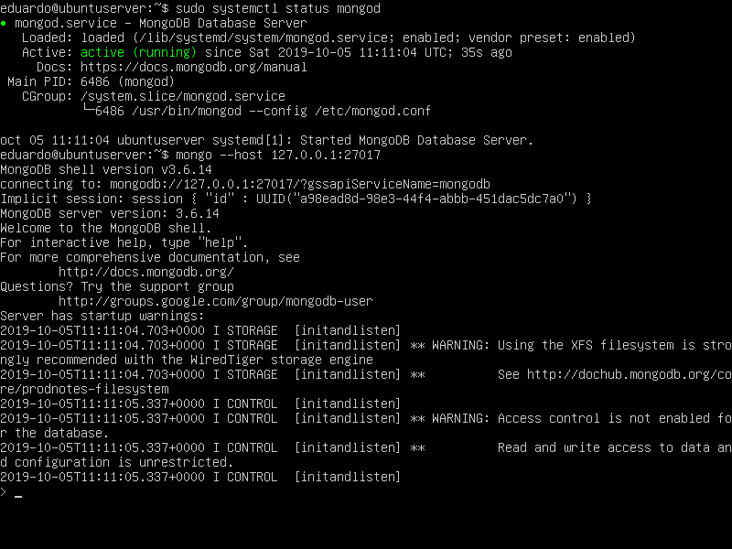

1. Add an administrator user.

* Create a new administrator user.

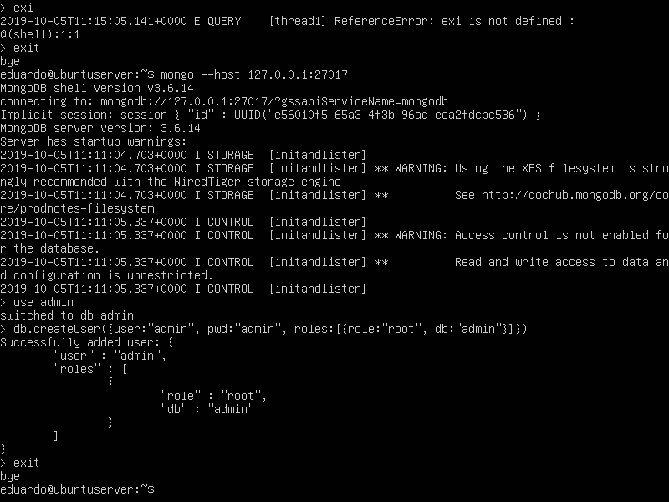

* Activate authentication, modifying the configuration file.

sudo nano /lib/system/system/mongod.service

* Modify “ExecStart” and add marked text. Then, save changes and exit nano.

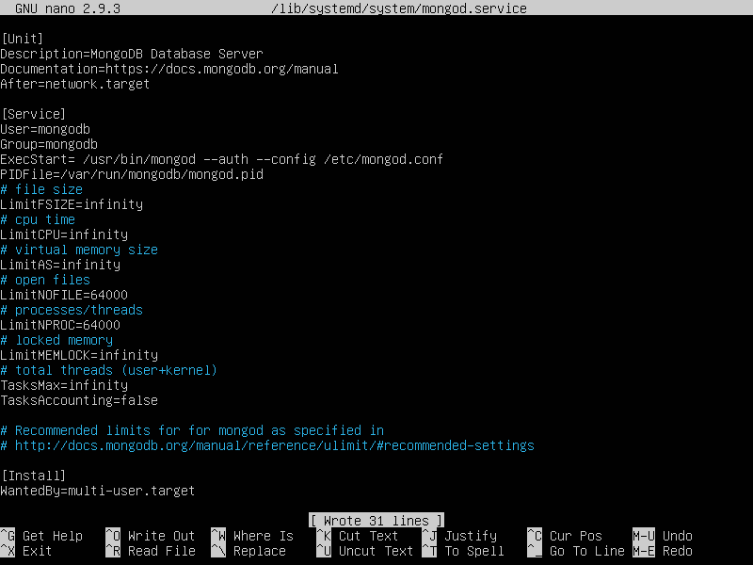

* Make restart to database for apply changes.

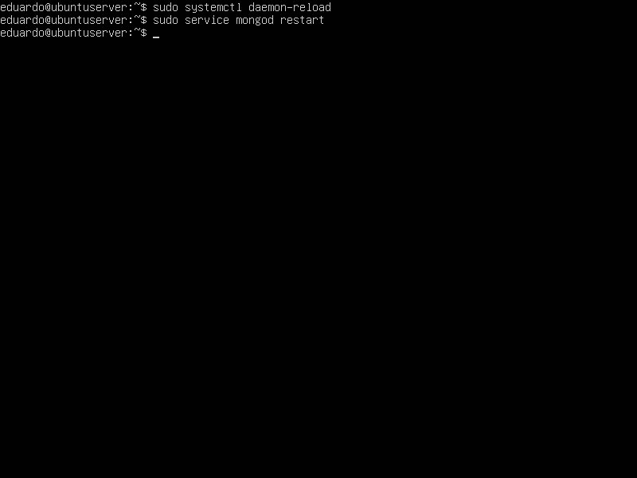

* Now, only authenticated users have access to the database.

